**Project Documentation**

**Educational Organisation Using ServiceNow**

**1.INTRODUCTION**

**Project Overview**  
The Educational Management System is a centralized platform designed to streamline administrative operations in schools or colleges. It enables efficient handling of student records, course registrations, admission workflows, and progress tracking, all built on the ServiceNow platform.

**Purpose**  
This project aims to replace error-prone manual processes with digital workflows using ServiceNow's capabilities. It enhances transparency, automates approval stages, and ensures timely communication between students and the academic administration.

**2.IDEATION PHASE**

**Problem Statement**

Educational institutions often struggle with fragmented and manual handling of admissions, student data, and academic processes. Delays and miscommunication affect both students and staff.

**Empathy Map Canvas**

* **Who?** Students, Teachers, Academic Staff
* **Think/Feel?** Students are unclear about application status; staff overwhelmed by paperwork
* **See?** Inconsistent records, long queues, paper-based workflows
* **Say/Do?** Repeated inquiries, use of physical forms
* **Hear?** Frustration over delays and lack of updates
* **Pain?** No real-time tracking, limited access control
* **Gain?** Organized digital process, timely notifications, better user experience

**Brainstorming**

Considered:

After evaluating options like Excel-based logs and manual registers, ServiceNow was selected for its structured workflow engine and scalability.

**3.** **REQUIREMENT ANALYSIS**

**Student Journey Map**

Student logs in → Applies for admission/course → System triggers approval → Faculty and HOD approve → Notification sent → Admission or enrollment confirmed

**Solution Requirements**

To meet the needs of a streamlined and automated car request process, the following components were required:

* Custom Catalog: "Educational Services"
* Categories: Admissions, Academics, Student Support
* Catalog Items: Admission Application, ID Card Request, Grade Report
* Role-based access (student, faculty, admin)
* Custom tables for admissions and academic progress
* Multi-level approval workflows
* Notifications for approvals and rejections

**Data Flow Diagram**

User→Service Portal→Catalog→Request Form→Workflow→Task Table

↓

Notification → Mail → User/Group

**Technology Stack**

* **Platform:** ServiceNow
* **Scripts:** JavaScript (Glide APIs), HTML
* **Modules:** Service Catalog, Workflow Editor, Notifications, Tables, Access Control

**4. PROJECT DESIGN**

**Problem-Solution Fit**

Manual educational processes are slow and untrackable. The solution includes categorized catalog items, automated multi-level workflows, and notification systems, all improving administrative effectiveness and student satisfaction.

**Proposed Solution**

To address the problem effectively, the following components were implemented:

* **Catalog:** Educational Services
* **Categories:** Admissions, Academics, Student Support
* **Catalog Items:** Admission, ID Request, Grade Report
* **Custom Role:** student_role, faculty_role
* **Groups:** Academic Office
* **Custom Tables:** u_admission, u_student_progress
* **Workflows:** Multi-tier approval with final confirmation tasks
* **Notifications:** Email alerts for status updates

**Solution Architecture**

* **Frontend:** Service Portal for requests
* **Logic Layer:** Workflow Editor, UI Policies
* **Backend:** Custom tables and dictionary entries
* **Notifications Layer:** Dynamic email templates for approvals/rejections
* **Access Control:** Role-based with defined permissions

**5. PROJECT PLANNING & SCHEDULING**

During this phase, the project was broken down into manageable development steps, ensuring modular implementation and validation. Key activities included:

* **Catalog Creation:** The "Educational Services" catalog was created to serve as the entry point for student and staff requests.
* **Category Design:** Categories such as Admissions, Academics, and Support were added for logical grouping of services.
* **Item Configuration:** Each catalog item (Admission, ID Card Request, Grade Report) was added with detailed descriptions, associated forms, and images where required.
* **User & Role Management:** Roles like student_role and faculty_role were created and users assigned appropriately. Groups like "Academic Office" were established to handle tasks.
* **Table Design:** Custom tables (u_admission, u_student_progress) were created and structured with fields for capturing relevant data like student grades, contact information, application status, etc.
* **Workflow Development:** Approval workflows were set up involving faculty and HOD, followed by backend task handling by academic office members.
* **Portal & UI Setup:** Catalog visibility, dynamic forms, and user-specific access controls were configured in the Service Portal.
* **Notification Integration:** Email notifications were designed using HTML templates to inform users about approval/rejection status with dynamic content.
* **Manual Testing:** Each functionality was tested step-by-step to ensure consistency, correctness, and complete process coverage.

**6. IMPLEMENTATION WORKFLOW**

This phase outlines the sequence of steps performed in implementing the **Educational Management System**:

**Step 1: Setting Up ServiceNow Instance**

1. Sign up for a developer account on the ServiceNow Developer site “https://developer.servicenow.com”.
2. Once logged in, navigate to the "Personal Developer Instance" section.
3. Click on "Request Instance" to create a new ServiceNow instance.
4. Fill out the required information and submit the request.
5. You'll receive an email with the instance details once it's ready.
6. Log in to your ServiceNow instance using the provided credentials.
7. Now you will navigate to the ServiceNow

**Step 2: Create a Update Set**

* Click on All >> Local update sets.
* Click on new
* Enter the Details Name: Educational Organisation >> Click on Submit and make Current

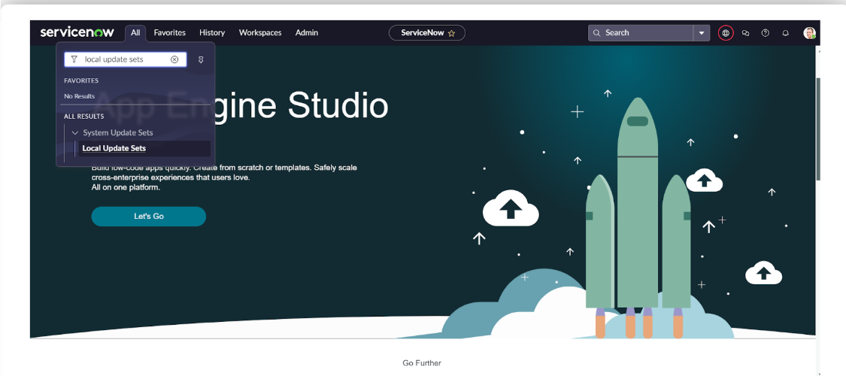

**Step 3: Create a Table**

* All >> Tables.
* Click **New**
* Enter the Label (Anything you want): Salesforce >> Click on Name it will Automatically generate Api name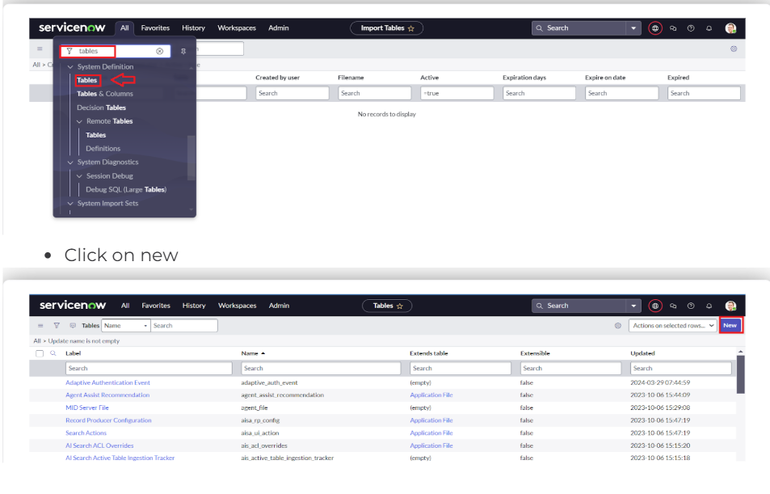

**Step 4: Create Admission Table**

* Create an Admission Table with Columns given.
* Select Extends Table >> Salesforce and also Select Add module to menu >> Salesforce.
* Create Fields as shown

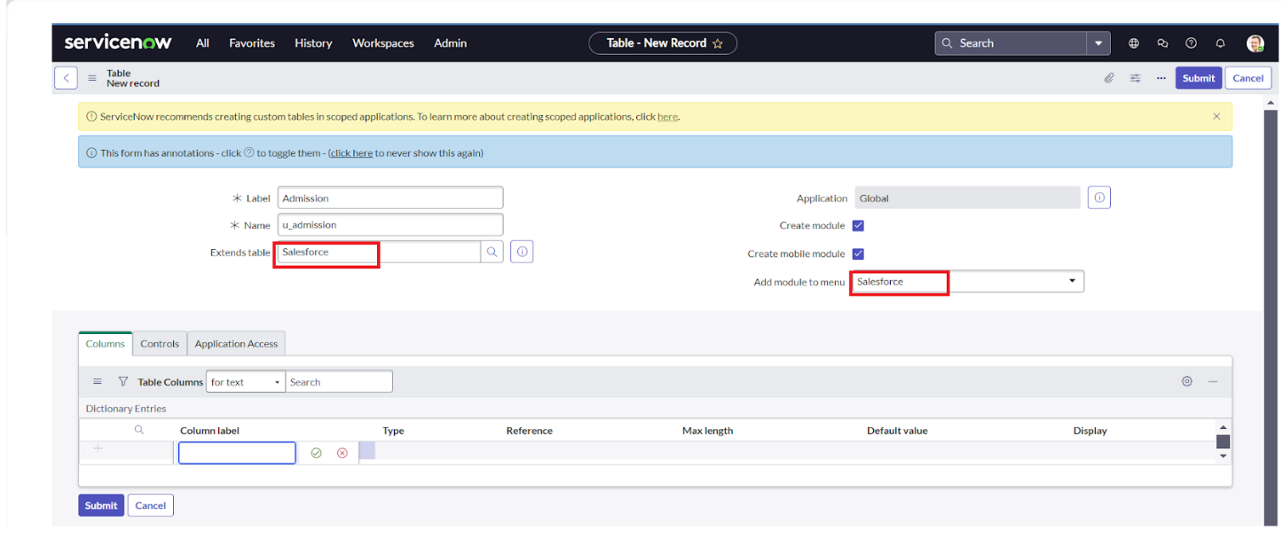

**Step 5: Create Student Progress Table**

* Create a Student Progress Table with Columns given.
* Select Add module to menu >> Salesforce.
* Create Fields as shown:

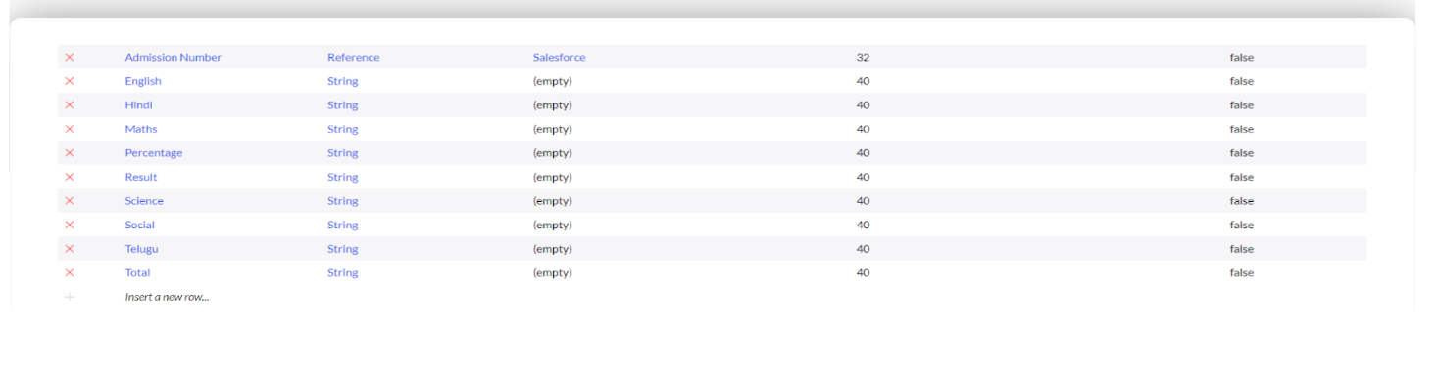

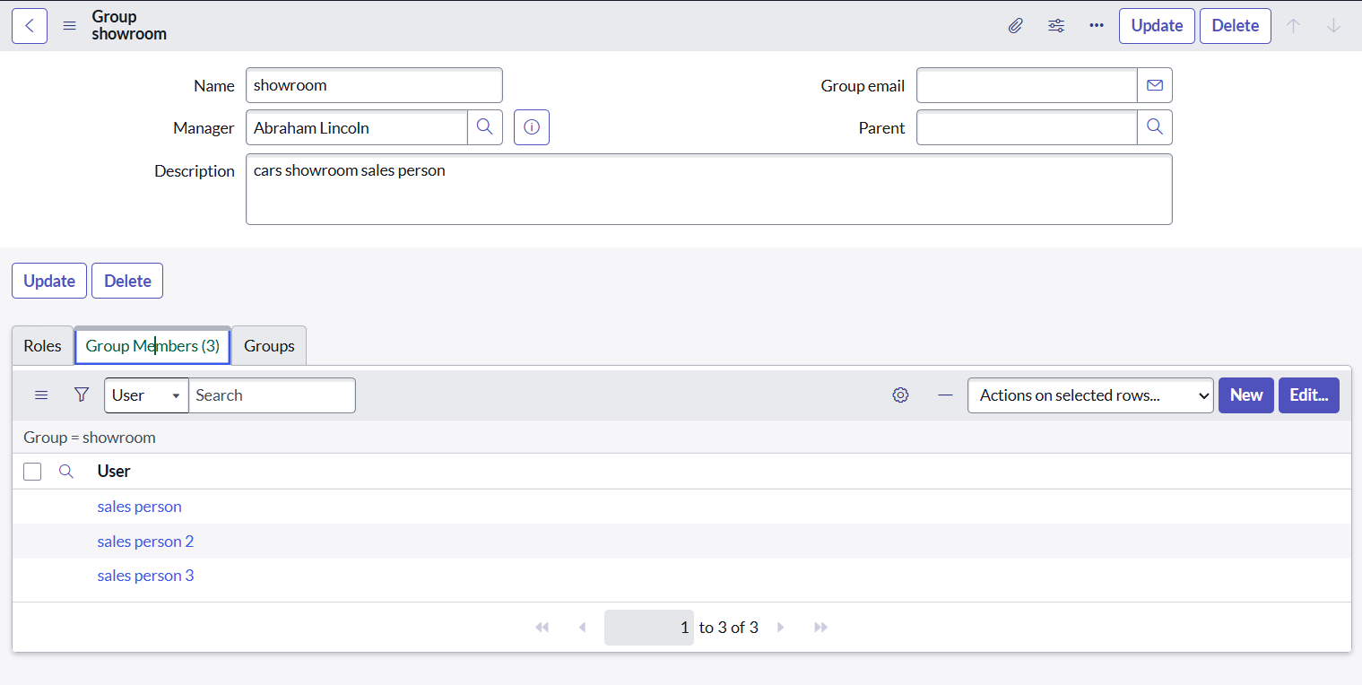

**Step 6: Configuring Table form for Student Progress Table**

* In the Student Progress Table Page, Click on Layout form.

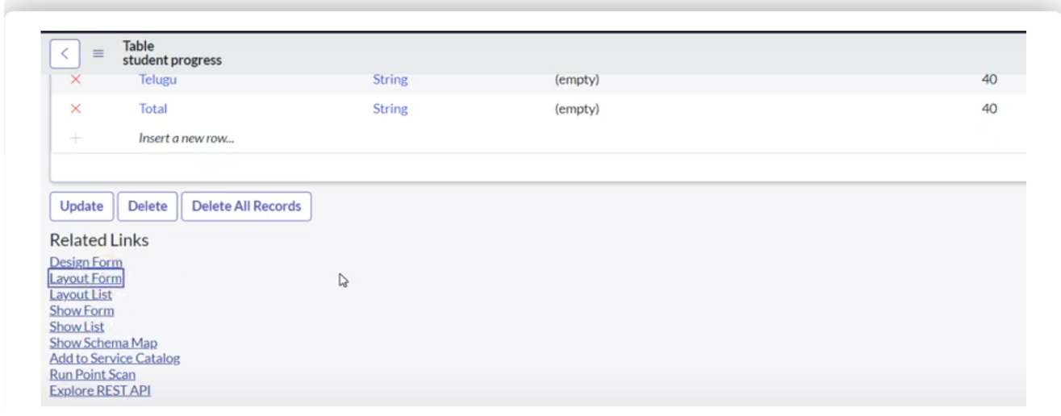

**Step 7: Creating Form Design For Sales Force Table**

1. All >> System Definition >> Tables.
2. In Label Search for Salesforce and open.

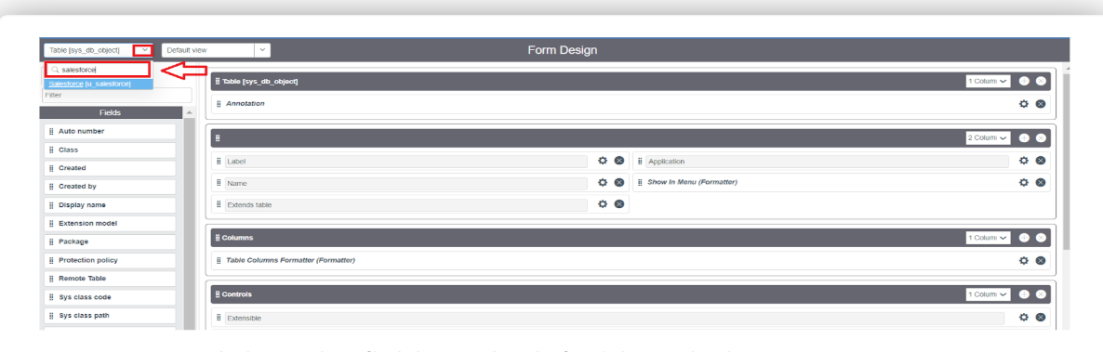 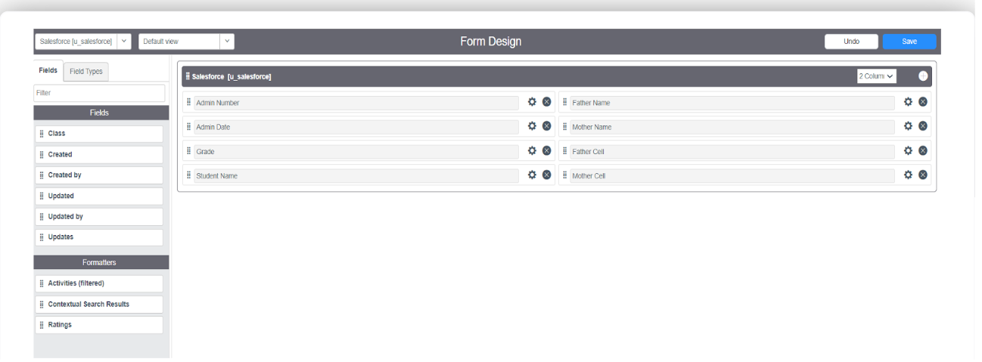

**Task: Creating Form Design For Admission Table**

Follow the same steps as Activity1, Configure the fields as below and Save. 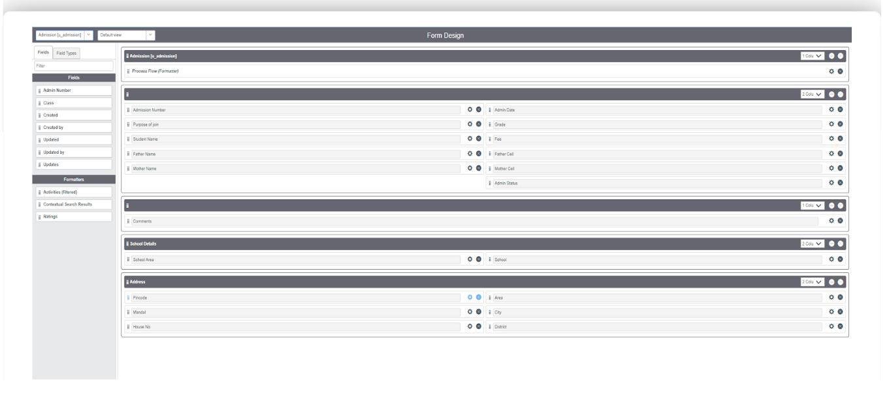

**Task: Creating Form Design For Student Progress Table**

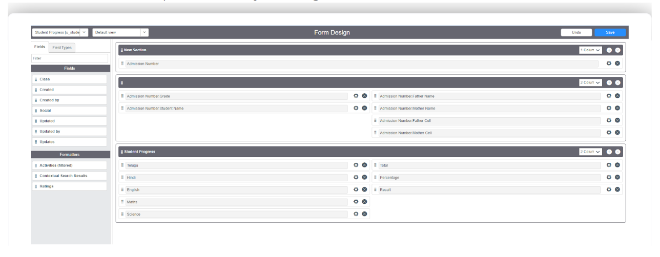

* **Task: Creating Number Maintenance For Admin Number**
* All >> Number Maintenance >> New
* Fill the details >> Submit.

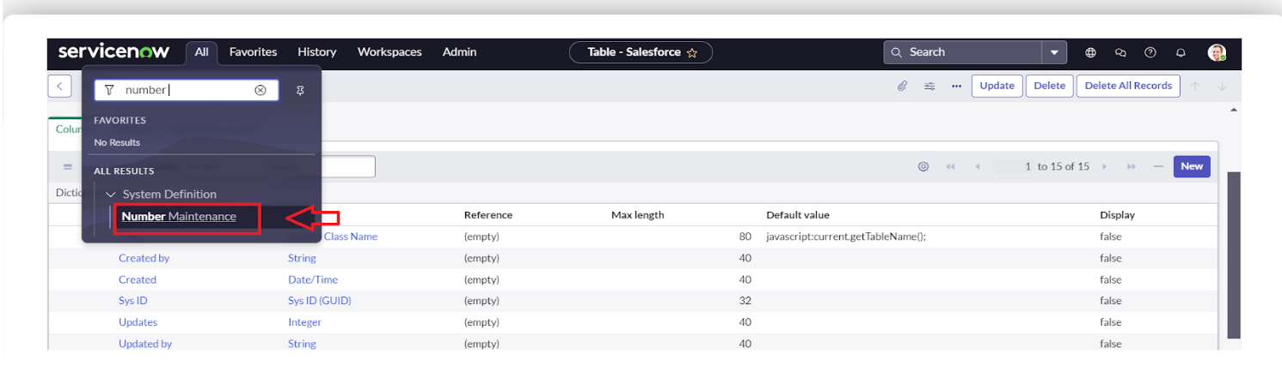

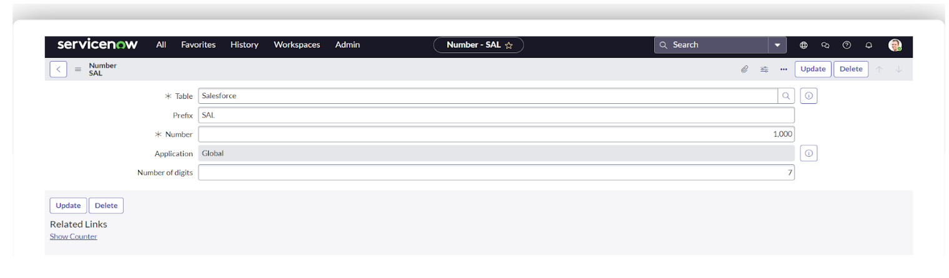

* **Notification: Creating Process Flow For Admission Table**
* All >> Process Flow>> New.
* Fill the Details as given Below

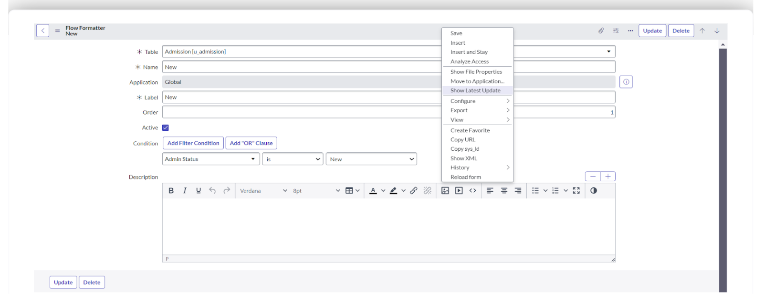

* Right Click on toggle and click on the save .
* Replace the Name and Label as below and click on Insert on stay.

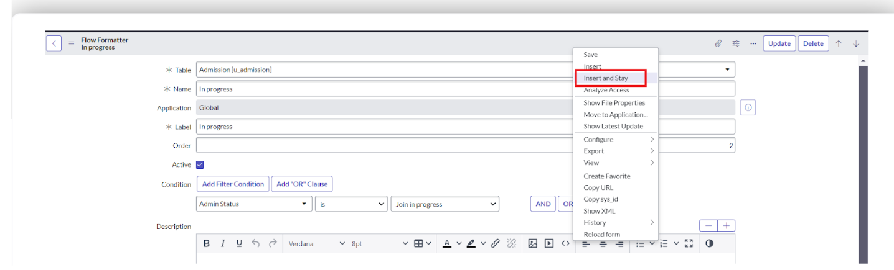

* Replace the Name and Label in order and click on Insert on stay. Joined >> Rejected >> Rejoined >> Closed >> Cancelled.
* Order should be New >> InProgress >> Joined >> Rejected >> Rejoined >> Closed >> Cancelled.
* **Task: Client Script**
* All >> Client Scripts >> New.
* Fill the Details as given.

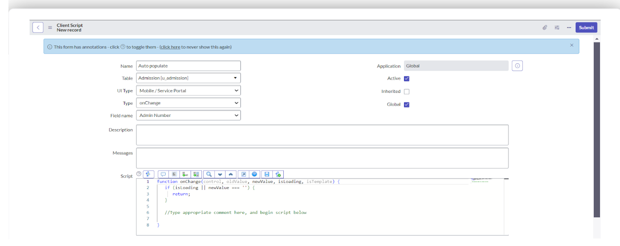

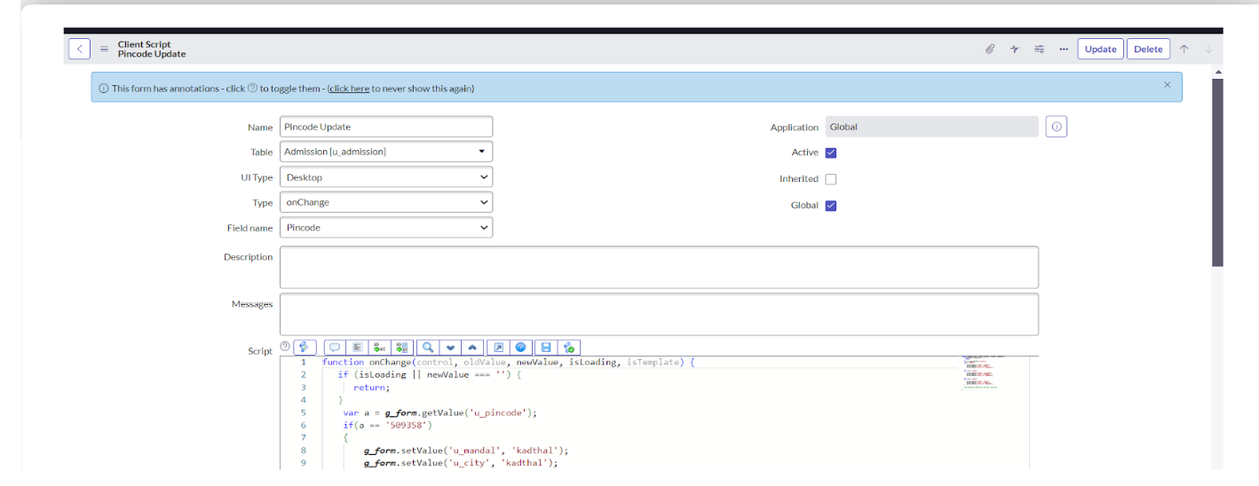

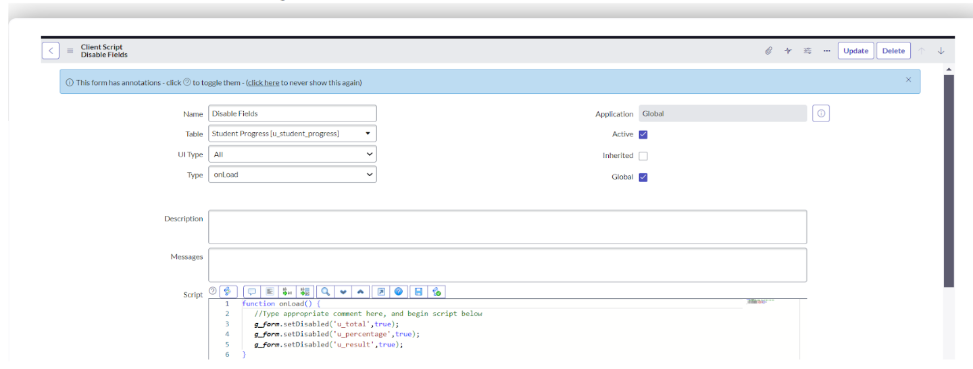

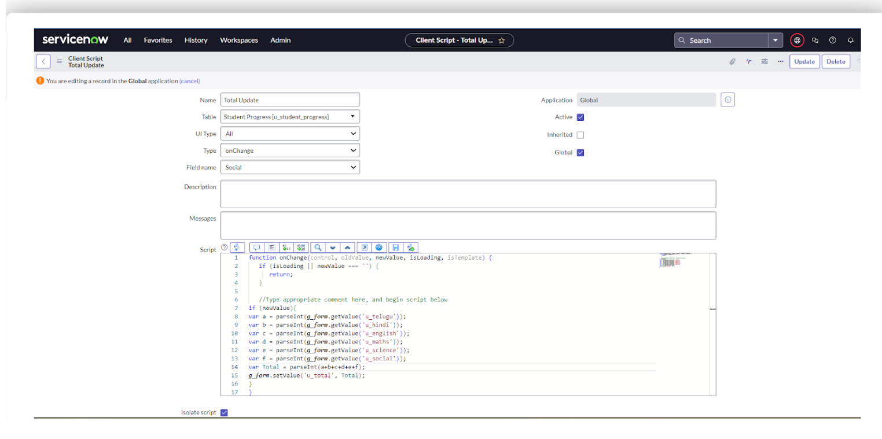

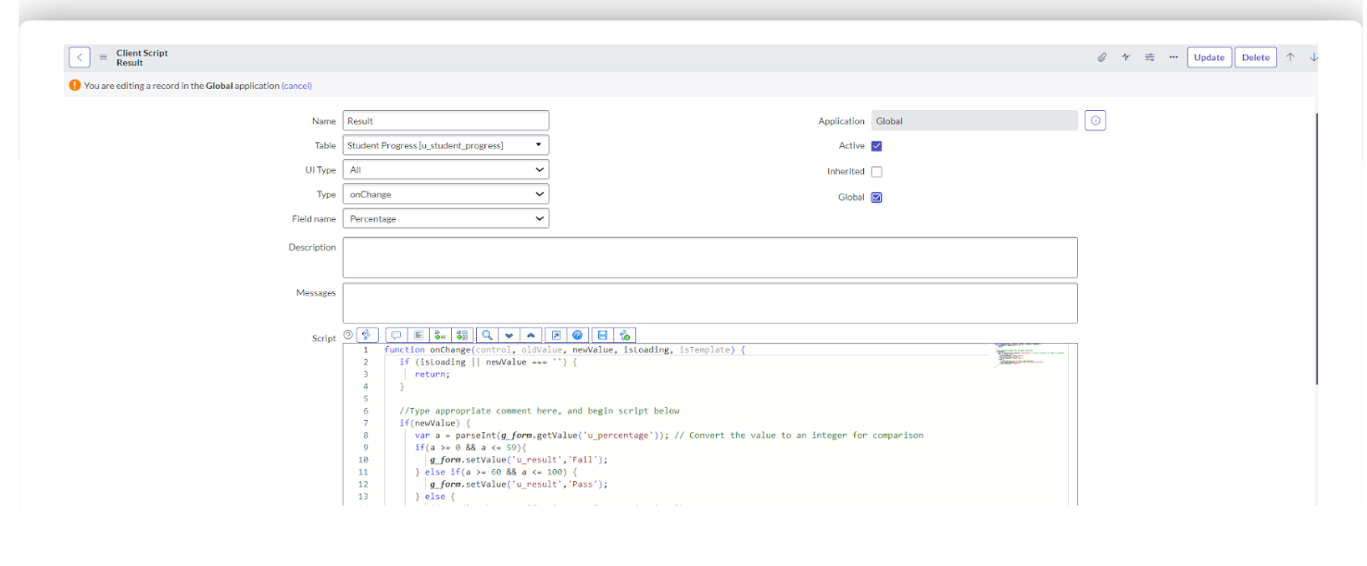

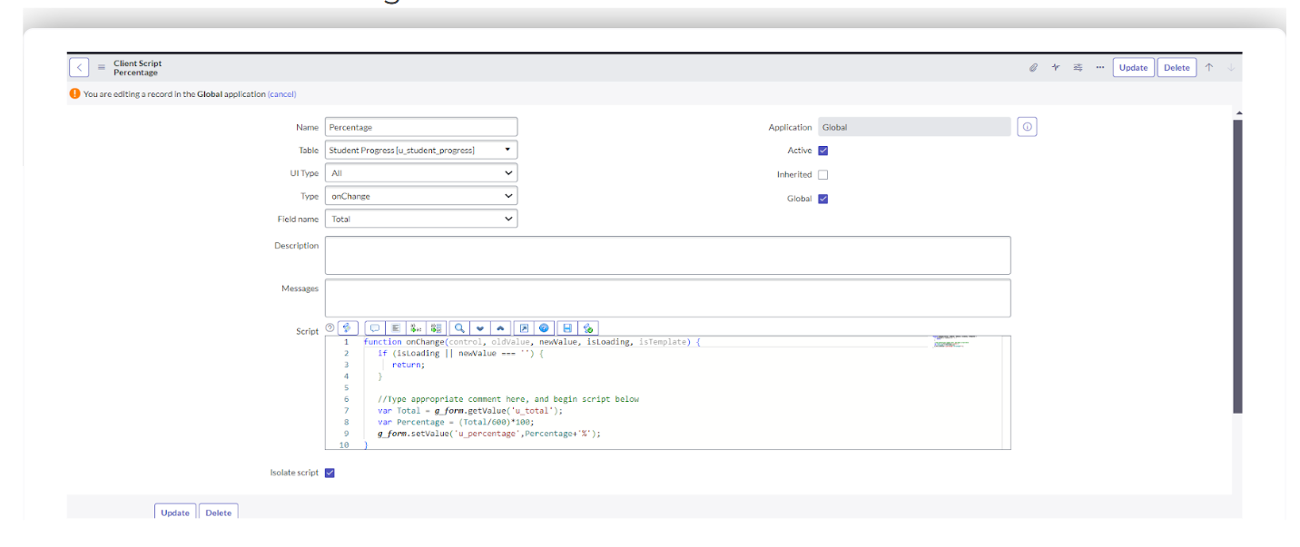

**Result:**

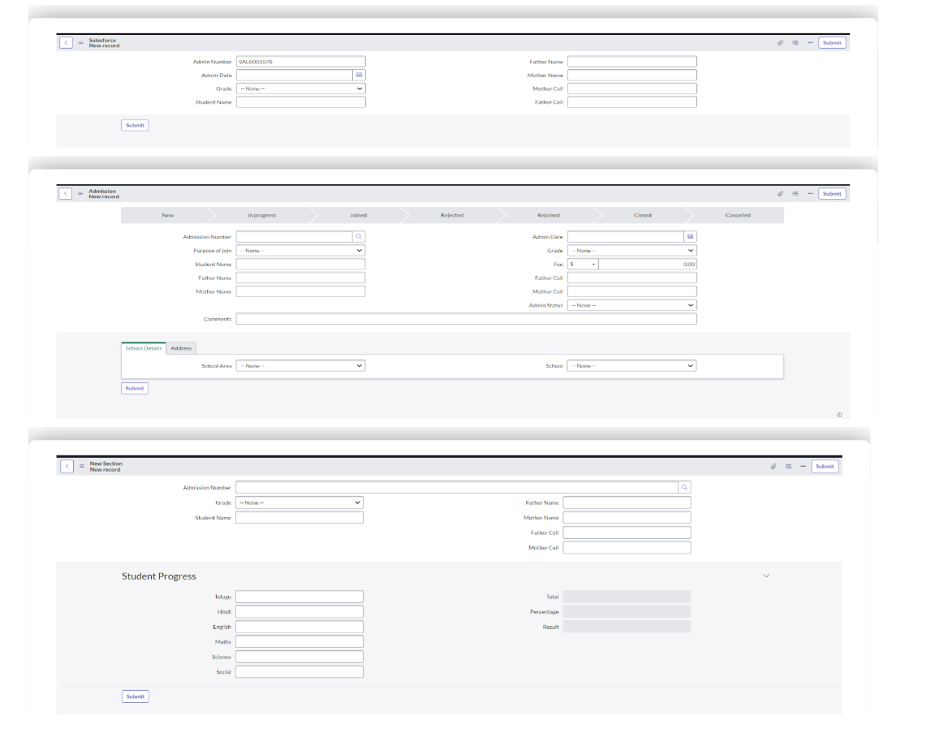

**7. FUNCTIONAL AND PERFORMANCE TESTING**

**Performance Testing**

**Performance and Functional Testing** involved checking every module and step in the workflow. Key validations included:

* **Catalog Display:** All items and categories visible under "Educational Services".
* **Form Accuracy:** Fields loaded correctly and accepted valid inputs.
* **Workflow Execution:** Requests routed to appropriate approvers with state tracking.
* **Email Delivery:** Notifications triggered instantly with correct content.
* **Data Consistency:** Entries correctly updated in u_admission and u_student_progress tables.

**8. ADVANTAGEDISADVANTAGES**

**Advantages**

* **Improved Efficiency:** Reduces manual work and speeds up request handling.
* **Error Reduction:** Validations prevent incorrect data entries.
* **Real-Time Notifications:** Keeps stakeholders updated at each stage.
* **Scalability:** Future academic services can be added easily without structural overhaul.

**Limitations**

* **Dependency on ServiceNow Expertise:** Requires administrators familiar with platform scripting and configuration.
* **Initial Complexity:** Workflow setup and portal tuning may take considerable time during the first phase.

**9. CONCLUSION**

The Educational Management System developed using ServiceNow provides an integrated, scalable, and efficient solution for managing key academic workflows such as admissions, progress tracking, and student support. It ensures structured communication, automated approvals, and transparent operations, enhancing the overall student and faculty experience.

**10. FUTURE SCOPE**

To make the system more robust and comprehensive, the following enhancements are proposed:

* **Feedback Module:** Allow students to rate and provide feedback on services or academic support.
* **Role-Based Dashboards:** Interactive dashboards for admin, teachers, and students with metrics and analytics.
* **Messaging Integration:** Notify students via WhatsApp or SMS in addition to emails.
* **Bulk Operations:** Enable mass course enrollment, attendance tracking, and batch promotions.
* **Payment Gateway Integration:** Allow students to pay application or tuition fees through the portal securely.